# **Moment.**

Build an end to end application match below requirement.

* Can Upload the images into DB;
* Can config the user id
* Backend expose micro service with Json message;
* App/Client side display the images for this user;
* 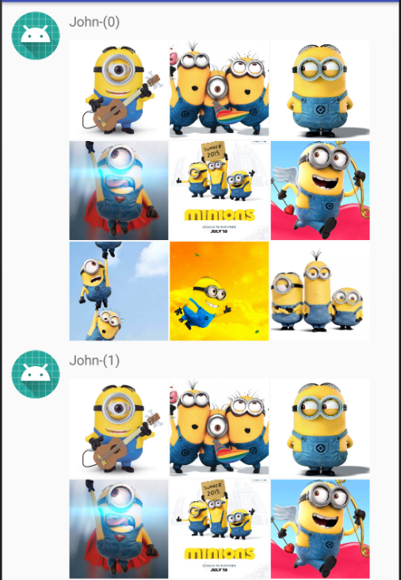
* The image can be auto enlarged once click it.



* In the large image page, there is slide bar according to the images amount;
* The images can be scrolled and the slide bar will be changed accordingly;

